**Screening for mental health in children and young people attending epilepsy clinics**

**(an Edinburgh Children’s Hospital Charity funded pilot project)**

**Dr Kirsten Verity, Paediatric Neuropsychologist (RHSC, Edinburgh)**

**Dr Catriona George, Clinical Psychologist (RHSC, Edinburgh)**

**Suzanne Felix, Assistant Psychologist (RHSC, Edinburgh)**

**Background**

This project was set up with the purpose of identifying children and young people with epilepsy (CYPwE) who are at risk of developing mental health problems or problems with learning. From previous research we know that there is a significantly higher risk of social, emotional, behavioural and learning difficulties in CYPwE, even when compared with other paediatric populations with chronic physical health problems. If these co-morbid problems are identified at an earlier stage and appropriate early intervention offered, it may be possible to prevent more serious problems developing later on. This approach is supported by a number of recent political drivers e.g. Mental Health Strategy (2017); Epilepsy 12 report (2012); RCPCH State of Child Health report (2017).

**Screening Methodology**

Our aim was to focus on those CYPwE whose mental health is less likely to be monitored and therefore where mental health problems more likely to go unidentified and untreated. Therefore our inclusion criteria are young people between the ages of 5 – 18, attending mainstream school and who are not already known to CAMHS. The project is currently being carried out within a neurology epilepsy clinic in RHSC. Families complete the screening questionnaires in the waiting room before attending their routine neurology review appointment.

Using two questionnaires, a **Screening** methodology was developed. A traffic light system is used to indicate level of difficulty experienced by each family.



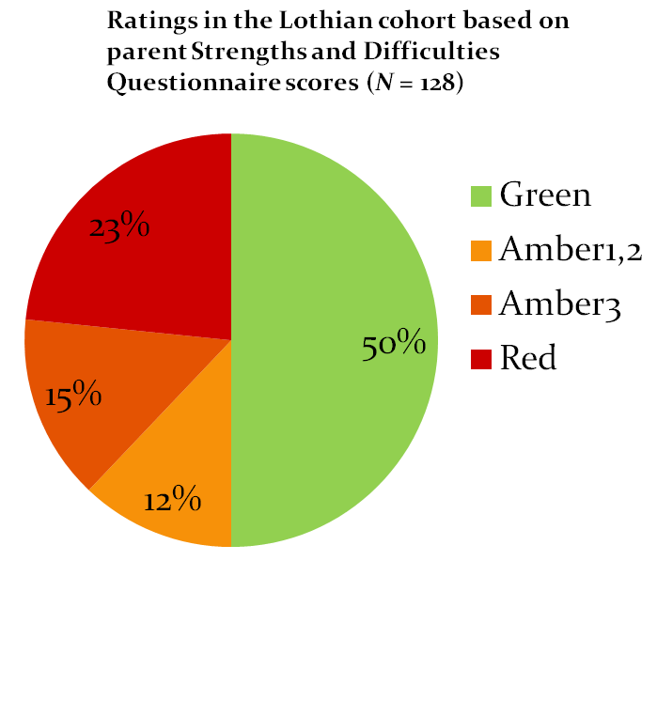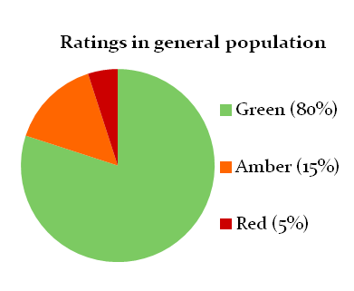Our findings to date indicate a high level of need in comparison to the general population.

**Intervention Pathway**

We are currently 5 months into year two of the project and our focus is now on development of an **Intervention Pathway** for those CYPwE are you a identified as being at risk. The development of this pathway has involved making links with third sector colleagues working in the community to ensure quality and maximise the use of already existing resources, such as Epilepsy Scotland Youth Group and Children’s Health Scotland Self Management Groups. These services can also provide individualised intervention, when young people do not meet the threshold for CAMHS input.

In addition, we have developed two **Parent Workshops** for parents of primary and secondary aged children, jointly with Epilepsy Scotland, and are currently piloting the six week **Psychosocial Intervention in Epilepsy** (PIE; Dorris et al., 2017) group for 12 – 17 year olds. The PIE group is run jointly between psychology and epilepsy nursing. Problem specific, individualised **Self Help materials** are provided for those with milder levels of difficulty (i.e. Amber 1 & 2 range) or who are currently unable to access the interventions available (see pathway below).

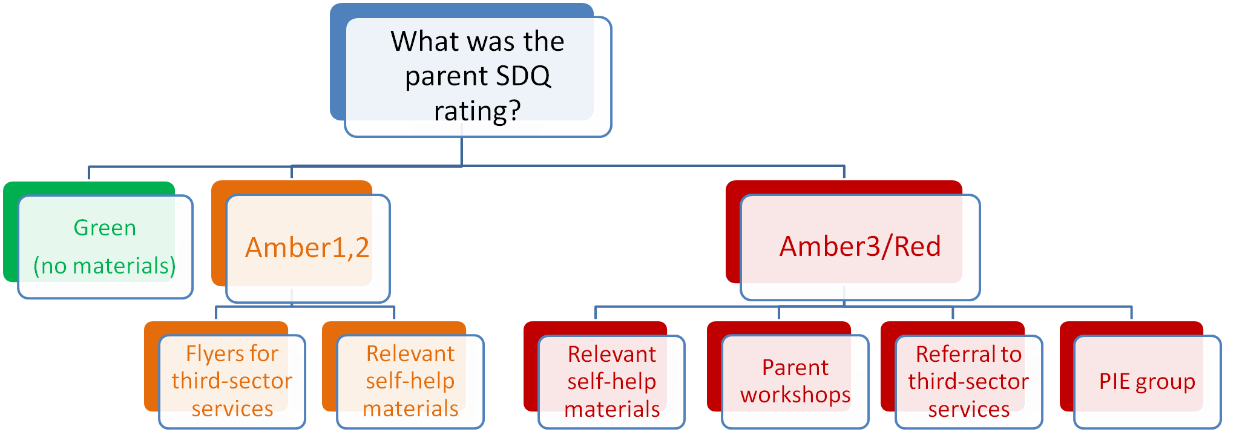

**Next Steps**

Next steps for the project will be to publish evaluation data on the effectiveness of both the screening and pilot interventions and to develop a computerised version of the screening protocol in order for the pathway to be sustainable.

The Scottish Paediatric Epilepsy Network (SPEN), a national Managed Clinical Network, has expressed an interest in using the screening methodology to scope the needs of CYPwE nationally.

**Acknowledgements**

Dr Ailsa McLellan, Consultant Paediatric Neurologist (RHSC, Edinburgh)

Dr Jay Shetty, Consultant Paediatric Neurologist (RHSC, Edinburgh)